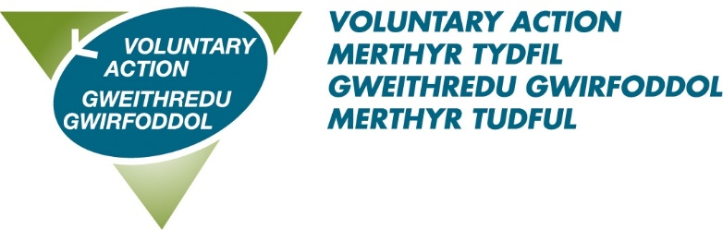
Guidance Notes for Making a Nomination

Voluntary Action Merthyr Tydfil
Annual Volunteer Recognition Awards 2026

Every year thousands of individuals and groups volunteer across the Merthyr Tydfil County Borough giving their time, energy, skills and commitment to help others in their community.

VAMT’s Volunteer Recognition Awards are designed to recognise and honour outstanding people and organisations that have made a significant contribution to our community, through their volunteering efforts. We encourage you to nominate individuals and groups who you feel have made a significant contribution, and who you feel deserve to be considered for an award.

The categories of awards are:

- Young Volunteer of the Year (25 and under)
- Volunteer of the Year (26 and over)
- Community Group / Charity of the Year
- Trustee
- Outstanding Achievement

Nomination Procedure (Individual award)

- A nomination form must be completed for each person being nominated.
- If you wish to nominate an individual for more than one category of award (eg, Volunteer of the Year and Outstanding Achievement), then a nomination form must be completed for each category.
- Nominees must have volunteered in the County Borough of Merthyr Tydfil during the past year.
- The nominator should have known the nominee for a minimum of six months and be able to give an accurate and detailed account of the volunteering undertaken by the nominee.

Nomination Procedure (Community Group / Charity)

- A nomination form must be completed for each Community Group or Charity being nominated.
- Nominations for the Community Group or Charity of the Year Award must be made by a volunteer, partner organisation or beneficiary from the nominated Group/Charity.
- The nominated Community Group/Charity must be based or working within the Merthyr Tydfil County Borough.

Exemptions

- Paid members of staff of VAMT and its member organisations are exempt from these awards.
- Individuals cannot nominate themselves.
- Individuals cannot be nominated by a partner or family member.
- Voluntary Action Merthyr Tydfil Staff and Trustees are exempt from nominating individuals and Community Groups/Charities for awards.

Rules for all categories

Personal details provided on all nomination forms may be passed on to partner organisations and to the media for publicity purposes. If you are not willing for any information to be shared in this way or if you do not wish media organisations to contact the nominee or nominator, please let us know as soon as possible.

- Please ensure that the information provided is relevant and unique to the nominee. The information should not be replicated nor duplicated for another nominee.

- Please note that whilst all nominees will be recognised, there is just one award winner for each category.

- An independent panel will be convened to review each nomination against a set of criteria, in order to determine the overall winner for each category.

- The panel will rely solely on the content of the nomination form and will work together to agree consensus of the category award winner.

- The decision of the panel is final.

- The panel reserves the right to not make an award in any particular category, if they feel that the nominations are not suitable and/or lack sufficient information on which to base a decision.

- No feedback will be given on the panel’s discussions or decision-making.

Submitting your nomination form

You may submit your nomination form in the following ways:

- By post - mark the envelope ‘Private and confidential’ and post to Frances Barry, Voluntary Action Merthyr Tydfil, Voluntary Action Centre, 89-90 Pontmorlais, High Street, Merthyr Tydfil CF47 8UH.

- Via email - to frances.barry@vamt.net

NB: Completed nominations (via post or email) must be received by Friday 10th April 2026 at 12 Noon. Nomination forms received after the closing date will not be considered.

To obtain further copies of the nomination form, information and rules, contact Fran on 07958 132822 or download the forms from the Volunteering Section of our website.

https://vamt.net/en/volunteering/celebrating-volunteering/

If you need assistance completing the nomination form, please contact Fran using the email address or mobile number above.

