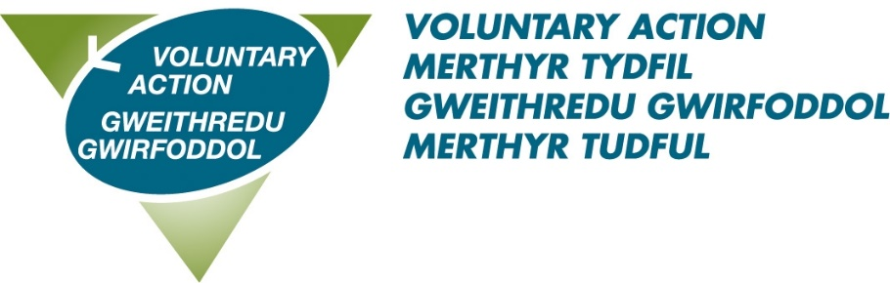
AGM Booking Form

25th September 2025 at 11 am
(10:45 arrival)
Voluntary Action Centre
CF47 8UH

I will be attending the AGM

in person
via Teams (an invite will be sent to you nearer the date)

Please give my apologies

Name ___________________________________________________

Organisation ______________________________________________

Email ____________________________________________________

Are you staying for lunch? Yes / No

Do you have any other requirements?

Dietary ___________________________________________________

Communication ____________________________________________

Please confirm your attendance by 12th September to
diane.lewis@vamt.net or telephone 01685 353900.

