



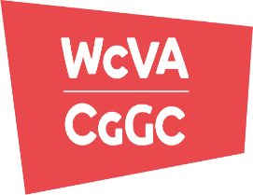

[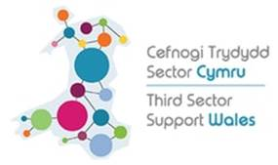](http://thirdsectorsupport.wales/)

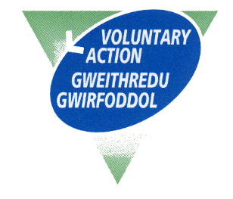



**YOUTH LED GRANTS**

**TERMS AND CONDITIONS**

**2025-2026**

The aim of the Youth Led Grants scheme is to support a range of small volunteering projects and activities, led and carried out by young people, with applications selected and recommended by a panel of young people aged 14-25.

**1. Applying for funding**

Each application will be from a Merthyr Tydfil based group of volunteers.

**2. The grant**

2.1. VAMT Youth Led Grants **will not** fund staff costs. As a volunteer run project we expect the projects that we fund to be supported within current provision or on a voluntary basis. **This does not include using the grant to pay for tutors to carry out pieces of work.**

2.2. Grants must be spent on the approved purposes, and receipts or invoices must be provided to show the amount of money spent.

2.3. The grant will not be increased in the event of an over spend on the project

2.4. **All money must be spent by, and receipts forwarded to VAMT by the 31st March 2026.** Any money left over must be repaid to VAMT.

**3. Priority areas for funding awards**

The Youth Led Grants will be expected to fund projects which contribute towards the seven Well-being of Future Generations Act (2015) goals. (Please note: not all projects will have to deliver against all seven goals)

1. [A Prosperous Wales](https://www.futuregenerations.wales/a-prosperous-wales/)
2. [A Resilient Wales](https://www.futuregenerations.wales/a-resilient-wales/)
3. [A More Equal Wales](https://www.futuregenerations.wales/a-more-equal-wales/)
4. [A Healthier Wales](https://www.futuregenerations.wales/a-healthier-wales/)
5. [A Wales of Cohesive Communities](https://www.futuregenerations.wales/a-wales-of-cohesive-communities/)
6. [A Wales of Vibrant Culture and Thriving Welsh Language](https://www.futuregenerations.wales/a-wales-of-vibrant-culture-and-thriving-welsh-language/)
7. [A Globally Responsible Wales](https://www.futuregenerations.wales/a-globally-responsible-wales/)

**4. The project / activities of the project**

4.1 The project must take place in Merthyr Tydfil. We will not fund activity that takes place outside of this area.

4.2. The panel values and supports equality & diversity and will not fund groups who exclude.

4.3 The panel encourages applicant projects to ask for permissions and undertake risk assessments for all activities.

**5. After the project**

The panel will require information from the project after they have received the funds. The panel members, VAMT staff plus external evaluator, might wish to visit your project as a means to gain the information. We will contact you to arrange a suitable time. It’s vital for you to keep evidence of your project taking place in the form of pictures, videos or case studies.

***Privacy Statement*** *VAMT takes your privacy seriously, and operates in line with The Data Protection Act 2018. Our lawful basis for processing your personal data is legitimate interest. We may collect data through emails, telephone calls and other forms that we require for certain activities, these forms may include risk assessments, activity forms and forms requesting training. We will use your personal data to (i) register you as a new volunteer, (ii) manage our relationship with you, (iii) to send you details of our services, (iv) keep you up to date with developments. This will be annually renewed with you for the duration of the project/service. For full information, including your rights as a data subject, please see our Privacy Policy at* <http://www.vamt.net/privacy-eng.php>