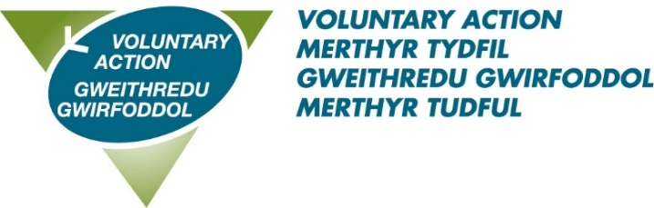

Job Title: Lead Officer – Health & Wellbeing – 28hrs per week**

About us: Voluntary Action Merthyr Tydfil (VAMT) is the County Voluntary Council (CVC) for the County Borough of Merthyr Tydfil and has existed since 1997. VAMT is a part of Third Sector Support Wales (TSSW) which is a network of support organisations for the third sector. Our shared goal is to enable the third sector and volunteers across Wales to contribute fully to individual and community well-being, now and for the future.

About this role:
Reporting to the Operations Manager, the postholder will support VAMT in its delivery of the TSSW Infrastructure Agreement, particularly the strategic aim to “strengthen representation and influence of third sector organisations”
The postholder will line manager the team of Community Coordinators and ensure accurate records are kept up to date via a bespoke CRM system.
To secure this great opportunity you will have experience of:
- working in the third sector at a strategic level
- partnership and collaborative working across sectors
- managing a team of staff

Benefits of working with us:
- A flexible working scheme
- 28 days annual leave (pro rata) rising to 33 on completion of 5 years’ service
- 8 bank holidays
- 3 concessionary days
- Enhanced sick pay
- A very generous pension scheme – 10% employer contribution
- Agile Working
- Employee support programme
**We are currently trialling a “4 Day Week” – this means 80% time for 100% salary and 100% output.
To download an application pack click here
This position is subject to a successful 6 month probationary period.
For an informal discussion about the role, please contact: claire.williams@vamt.net
Closing date: 31st March 2025, 12pm Interview date: 10th April 2025

