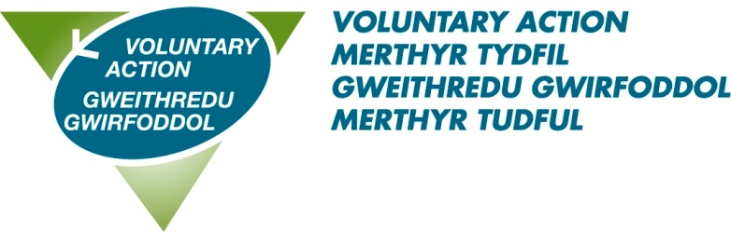

**TITLE: Lead Officer – Health & Wellbeing**

**HOURS: 28 hours per week**

**SALARY: £32654 (pro-rata) - £24711 (actual)**

**ANNUAL LEAVE: 28 days plus 3 concessionary days (pro rata)**

**ACCOUNTABLE TO: Operations Manager**

**LOCATION: Merthyr Tydfil**

|  |  |
| --- | --- |
| **Role Purpose:**  Reporting to the Operations Manager, the postholder will support VAMT in its delivery of the TSSW Infrastructure Agreement, particularly the strategic aim to *“strengthen representation and influence of third sector organisations”*  The postholder will line manager the team of Community Coordinators and ensure accurate records are kept up to date via a bespoke CRM system. | |
| **Main Responsibilities** | **Management**   * Undertake HR processes including, but not limited to, recruitment, induction and appraisal. * Provide effective line management support and supervision for staff aligned with this post, ensuring their work is of the required standard. * Provide project direction in line with strategic or organisational developments. * Collate, analyse and prepare timely reports on performance for funders.   **Engagement and Influencing**   * Develop and support local health and wellbeing networks. * Represent VAMT and its members on key partnerships at a regional and local level; * Identify opportunities for wider third sector involvement in the locality or region   **Development**   * Raise the profile of VAMT and its services through a variety of means including social media. * To facilitate participation and consultation in policy development at a local, regional and national level * Administer and monitor the Befriending and Dementia Grant ensuring reports are submitted on time to relevant funding bodies. |
| **Other** | * Attending and making good use of supervision * Deputise for other staff when necessary and appropriate * Undertaking training as required * Be prepared to work during evenings and at weekends from time to time (A flexi time system is in place) * Participate in internal working groups to further VAMT’s organisational development * Undertaking other duties which are not detailed in this job description, but which meet VAMT’s aims to assist and support the work of the voluntary sector in Merthyr Tydfil. |

PERSON SPECIFICATION

LEAD OFFICER - HEALTH & WELLBEING

|  |  |
| --- | --- |
| **Essential Criteria** | Education/training   * Degree level or equivalent relevant experience.   Direct experience of:   * Working within the third sector at a strategic level * Partnership and collaborative working across statutory and third sector * Engaging with people in communities/third sector groups * Facilitating networks/Forums * Preparing and delivering presentations and information sessions to varied audiences * Monitoring and evaluations processes * Managing individuals and projects, preferably within the third sector   Skills and attributes   * Ability to work on own initiative and within a pressured environment * Ability to prioritise workload and achieve deadlines * Ability to chair and manage meetings * Excellent interpersonal, networking and presentation skills with the ability to communicate effectively at a range of levels * Able to be creative and innovative in seeking solutions * Well developed IT skills and proficient in the use of digital office systems and social media platforms   Knowledge of:   * Legislation relevant to the role, eg: Social Services & Wellbeing (Wales) Act; Wellbeing of Future Generations Act * Safeguarding procedures and working within a policy framework * Equality, Diversity and Inclusion * Data Protection principles (GDPR) and issues of confidentiality * Third Sector Support Wales |
| **Desirable Criteria** | * Possession of a full current driving licence and access to private transport for use at work * Ability to communicate in Welsh |
| **Personal Qualities** | * Works co-operatively with others to get things done, willingly giving help and support to colleagues * Acts with integrity * Takes ownership for resolving problems, demonstrating courage and resilience * Positive about change, adapting to different ways of working * Asks for and acts on feedback, learning from experience and continuing to develop own professional skills and knowledge * Is approachable, developing positive working relationships and good team spirit * Knowledge, understanding and commitment to equality, diversity, and inclusion * A commitment to being an ambassador for the voluntary and community sector. |

The contents of this document will be subject to review from time to time in consultation with the post holder. Job descriptions may be amended to reflect and record such changes.