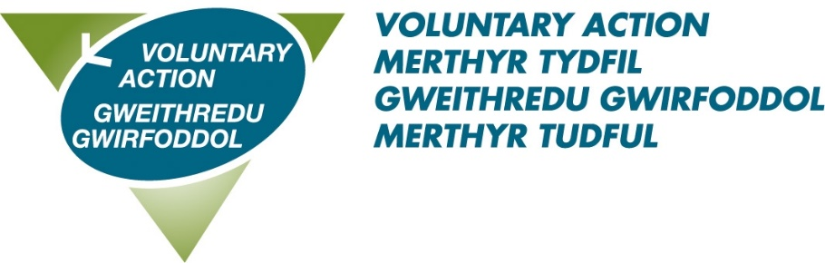
AGM Booking Form

26th September 2024 at 11 am
Merthyr Tydfil Football Club

I will be attending the AGM

Please give my apologies

Name ___________________________________________________

Organisation ______________________________________________

Email ____________________________________________________

Are you staying for lunch? Yes / No

Do you have any other requirements?

Dietary ___________________________________________________

Communication ____________________________________________

Please confirm your attendance by 12th September to
laura.johnson@vamt.net or telephone 01685 353900.

