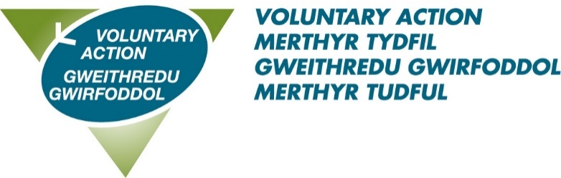

VOLUNTARY ACTION MERTHYR TYDFIL

JOB DESCRIPTION

Title: Business Support Officer

Accountable to: Business & Finance Manager

Salary: £23,114

Hours: 37 hours per week

Term: Permanent

Location: Merthyr Tydfil

Role Purpose:

To support VAMT in its delivery of services to its members and stakeholders, by providing high quality, efficient and effective administrative support in finance, personnel, health and safety and organisational functions.

Main Responsibilities | - Being a main point of contact and fielding enquiries in person or by phone/email  - Carry out financial processes to include raising sales invoices and processing supplier invoices from receipt to point of payment using Xero accounting software  - Support organisational compliance with health and safety relating to staff and building  - Scheduling meetings, taking minutes and assisting in the planning and organisation of events  - Update VAMT’s social media platforms, including blog and website  - Proficient management of office diaries and monitoring multiple email addresses  - Provide administrative and financial assistance for grant schemes administered by VAMT and collate monitoring in line with funder requirements  - Ensure accurate data entry to a bespoke CRM system. Providing reports as necessary  - Liaise with contractors providing services within the building  - Oversight of office inventory, ensuring adequate supply of consumables
Other | - Attending and making good use of supervision  - Deputise for other staff when necessary and appropriate  - Undertaking training as required  - Be prepared to work during evenings and at weekends from time to time (A flexi time system is in place)  - Participate in internal working groups to further VAMT’s organisational development  - Undertaking other duties which are not detailed in this job description, but which meet VAMT’s aims to assist and support the work of the voluntary sector in Merthyr Tydfil

PERSON SPECIFICATION
Business Support Officer

Qualifications, skills and experience | Essential:  - A positive “can-do” approach, and to be naturally curious with the ability to take ownership and think through tasks  - Two years direct experience in an office environment  - Minute Taking  - Excellent communication skills with a proven ability to deal confidently with service users, professional partners and other individuals and agencies from diverse backgrounds  - Working knowledge of Office 365 applications  - Motivated and highly organised, with the ability to prioritise own workload  - Be able to ensure confidentiality where appropriate  - The ability to keep calm and polite and work effectively under pressure  - Experience of using accounting software  - Experience of updating Social Media within a work environment  Desirable:  - Experience of Xero Payroll  - Experience of Charity Accounting  - Experience of working with databases  - Understanding of HR processes  - Ability to communicate in Welsh
Personal Qualities | - Works co-operatively with others to get things done, willingly giving help and support to colleagues  - Acts with integrity  - Takes ownership for resolving problems, demonstrating courage and resilience  - Positive about change, adapting to different ways of working  - Asks for and acts on feedback, learning from experience and continuing to develop own professional skills and knowledge  - Is approachable, developing positive working relationships and good team spirit  - Knowledge, understanding and commitment to equality, diversity and inclusion  - A commitment to being an ambassador for the voluntary and community sector.

The contents of this document will be subject to review from time to time in consultation with the post holder. Job descriptions may be amended to reflect and record such changes.

