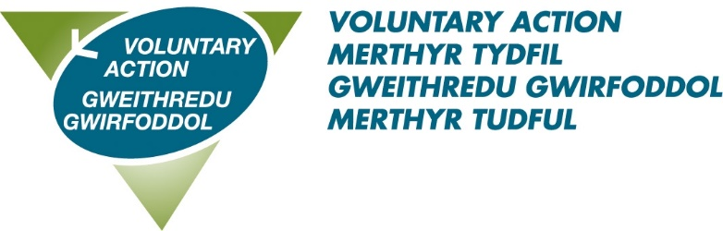

Job Title: Community Rail Officer

About us: Voluntary Action Merthyr Tydfil (VAMT) is the County Voluntary Council (CVC) for the County Borough of Merthyr Tydfil and has existed since 1997. VAMT is a part of Third Sector Support Wales (TSSW) which is a network of support organisations for the third sector. Our shared goal is to enable the third sector and volunteers across Wales to contribute fully to individual and community well-being, now and for the future.

About this role: To promote and develop the community railway lines on behalf of the Heads of the Valleys Railway Partnership. Working in partnership with the local community, business, and tourism to establish and implement a community rail development plan that will benefit the community and the railway.
The role of the Community Rail Officer is to support the Community Rail Partnership and have responsibility for the delivery of the Activity Plan that will be agreed by the regional steering group each year in line with the Wellbeing of Future Generations Act.
To secure this great opportunity you will have: excellent communication skills, the ability to work collaboratively across all sectors, excellent organisational skills, ability to support and manage volunteers, a proven track record in community development as well as an understanding of delivering against a development plan.

Benefits of working with us:
- A flexible working scheme
- 28 days annual leave rising to 33 on completion of 5 years service
- 8 bank holidays
- 3 concessionary days
- Enhanced sick pay
- A very generous pension scheme – 10% employer contribution
- Agile Working
This post is subject to a successful 6 month probation period.
To download an application pack please click here
Closing date: 7th September 2023 12 noon
Interview date: 20th September 2023

