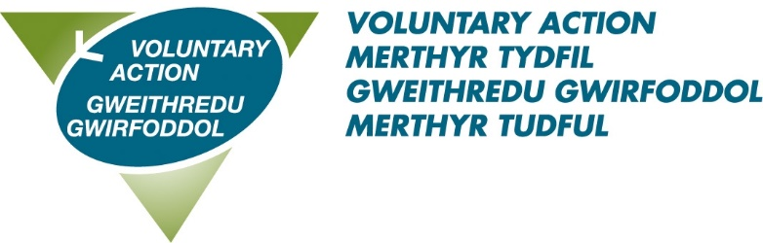

VOLUNTARY ACTION MERTHYR TYDFIL

**JOB DESCRIPTION**

**Title: Community Rail Officer**

**Accountable to: VAMT Community Development Lead**

**Salary: £27,344.00**

**Hours: 37 per week**

**Term: Permanent (subject to funding) or**

**Until 31.03.26 (renewed annually)**

**Location: Cwm Taf (RCT and Merthyr Tydfil)**

|  |  |
| --- | --- |
| **Role Purpose:**  To promote and develop the community railway lines on behalf of the Community Rail Partnership that will cover the routes from Treherbert, Aberdare and Merthyr to Cardiff. Working in partnership with the local community, business, and tourism to establish and implement a community rail development plan that will benefit the community and the railway.  The role of the Community Rail Officer is to support the Community Rail Partnership and have responsibility for the delivery of the Activity Plan that will be agreed by the regional steering group each year in line with the Wellbeing of Future Generations Act. | |
| **Main**  **Responsibilities** | In line with both the Well Being for Future Generations Act and its five ways of working and the 4 Pillars of Community Rail (Department for Transport), actively engage with Local Authorities, Train Operating Companies, Network Rail, other transport operators, Community Rail Network, local and regional economic development and tourism interests, local communities and businesses to establish priorities for local rail development, identify sources of funding and manage implementation of schemes that contribute to agreed Community Rail development plan objectives.   * To encourage community adoption of stations with the aim of enabling improvements to the environment and amenity of   local stations and community participation in the development of the railway. Participate in development of railway and  specific engagement and promotion of Station Adoption Schemes.   * To promote the utility and value of the local network and services at local and regional events, via community-based meetings, and local consultation forum. * To promote local and regional car free sustainable tourism initiatives which benefit the local community and retain wealth in the local economy with the relevant interests, via production of relevant publicity and marketing material and development of ticket offers and packages to encourage sustainable access to leisure and tourism. * To work with schools and youth groups on initiatives to   promote the railway and rail use among young people and develop local projects that capture this interest.   * To implement targeted wellbeing activities and educational experiences for local interest groups by facilitating trips to educate and inform on areas such as rail safety and active travel in order for them to consider safe public transport use. * To create increased local rail safety awareness and to work with local communities to resolve community safety, access   and personal security concerns at stations and on trains.   * To investigate beneficial uses for redundant railway buildings that support community and passenger interests. * To identify potential for development of additional tourism flows. * To manage the day-to-day administration of the Heads of the Valleys Railway Partnership, including internal and external relations with stakeholders, the public and the media. * To act as secretariat to support and write reports to the Heads of the Valleys Partnership steering group as required. * To manage and acquire funding for marketing, projects and events associated with Heads of the Valleys Railway Partnership. * To create a content plan and manage the partnership’s social media and online web presence. * To support the work of the Environment and Green Space Network in Merthyr Tydfil * To support the work of the Green Prescribing Network in RCT |
| **Other** | * Attending and making good use of supervision * Deputise for other staff when necessary and appropriate * Undertaking training as required * Be prepared to work during evenings and at weekends from time to time (A flexi time system is in place) * Participate in internal working groups to further VAMT’s organisational development * Undertaking other duties which are not detailed in this job description, but which meet VAMT’s aims to assist and support the work of the voluntary sector in Merthyr Tydfil. |

PERSON SPECIFICATION

Community Rail Officer

|  |  |
| --- | --- |
| **Essential Criteria** | Knowledge and Experience   * Ability to lead community development through engaging with public transport, local authorities, local community, industry, and professional bodies * Ability to implement and make recommendations to the Community Rail Development Plan * Must be familiar with the local area and community and other stakeholder groups   People   * Commitment to equality and diversity. * Ability to motivate others. * Ability to explain and train assistants, trainees, volunteers and work placements in work task and duties.   Judgement and Initiative   * Ability to work on own initiative and lead and work as part of a team. * Confident, enthusiastic, and self-motivated. * Ability to plan and prioritise workload effectively to meet set deadlines. * Good organisational skills   Communication   * Excellent written and verbal communication skills. * Ability to communicate effectively with the public and volunteers. * Ability to work with individuals at a variety of levels, internally and externally and in a range or organisations.   Resources   * Ability to manage a budget, obtain quotes and order project materials and services as directed. * Ability to keep accurate project records. * Ability to record and ensure accurate records of expenditure, including petty cash.   Confidentiality   * Understanding of the importance of confidentiality and always maintain a high professional standard of behaviour.   Other   * + Full driving licence and use of a vehicle.   + Appreciation and understanding of Welsh heritage and culture. |
| **Desirable Criteria** | Knowledge and Experience   * Knowledge of how the rail industry works * Familiar with public transport in the Community Rail Partnership region * Familiar with social value and social impact   Communication   * Ability to communicate through the medium of Welsh. |
| **Personal Qualities** | * Works co-operatively with others to get things done, willingly giving help and support to colleagues * Acts with integrity * Takes ownership for resolving problems, demonstrating courage and resilience * Positive about change, adapting to different ways of working * Asks for and acts on feedback, learning from experience and continuing to develop own professional skills and knowledge * Is approachable, developing positive working relationships and good team spirit * Knowledge, understanding and commitment to equality, diversity, and inclusion * A commitment to being an ambassador for the voluntary and community sector. |

The contents of this document will be subject to review from time to time in consultation with the post holder. Job descriptions may be amended to reflect and record such changes.