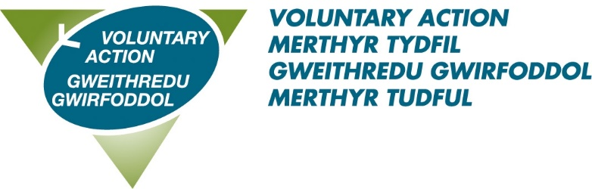

Job Title: Local Implementation Lead

About us: Voluntary Action Merthyr Tydfil (VAMT) is the County Voluntary Council (CVC) for the County Borough of Merthyr Tydfil and has existed since 1997. VAMT is a part of Third Sector Support Wales (TSSW) which is a network of support organisations for the third sector. Our shared goal is to enable the third sector and volunteers across Wales to contribute fully to individual and community well-being, now and for the future.

About the role:

We currently have a fantastic opportunity for an energetic, engaging and enthusiastic individual with experience of working across communities and building networks to join us as a Local Implementation Lead Officer. The role will support Lloyds Bank Foundation’s Development Team to develop and deliver their asset based ‘system change’ work with charities and a wide range of partners in Merthyr Tydfil.
Whilst this work continues to develop/evolve, we are looking for a person with a high tolerance for uncertainty, with a good eye for detail and an understanding of local issues and systems.

This post is subject to a successful 6 month probation period.

Benefits of working with us:
- A flexible working scheme
- 28 days annual leave rising to 33 on completion of 5 years service
- 8 bank holidays
- 3 concessionary days
- Enhanced sick pay
- A very generous pension scheme – 10% employer contribution
- Agile Working
For an informal discussion about the role, please contact: Claire Williams on 07946 495306
To download an application pack please click here
Closing date: 7th August 2023
Interview date: 23rd August 2023

