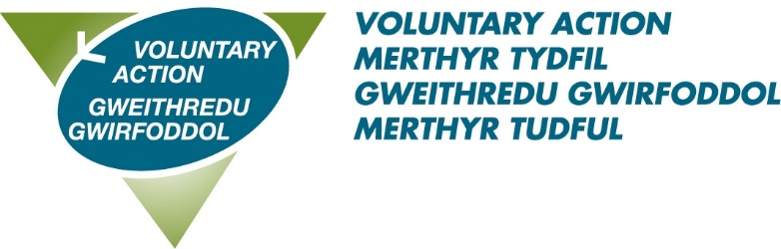

VOLUNTARY ACTION MERTHYR TYDFIL

JOB DESCRIPTION

Title: Local Implementation Lead

Accountable to: Health & Wellbeing Manager

Salary: £27,344

Hours: 37

Term: 2 years. Continuation subject to funding.

Location: Merthyr Tydfil

Role Purpose:

- To support Lloyds Bank Foundation’s Development Team to develop and deliver their asset based ‘system change’ work with charities and a wide range of partners in Merthyr Tydfil

Main Responsibilities | Work closely with the People and Communities Lead, Development Associates and others at Lloyds Bank Foundation to plan and shape the approach to the work.  To be the first and central point of contact for the Development Team in Merthyr Tydfil and will be handling enquiries and issues in a friendly, professional and efficient way.  Engage with a wide range of partners who have a focus on Children & Young People’s Mental Health.  Work collaboratively with third sector providers and public service partners to help develop the programme of work.  To work in partnership with VAMT members and their beneficiaries to facilitate their participation.  Facilitate appropriate networks/fora to meet the needs of the organisation/members and is of benefit to the work programme.  Organise and deliver multiple meetings/workshops.  Disseminate news and information via networks, website, newsletters, blog, social media.  Represent VAMT at a range of local, regional and national meetings relevant to the role.  Collect, collate and analyse data and information.  Record all interactions on the CRM and prepare regular case studies.  Provide quarterly update reports as required.
Other | Attending and making good use of supervision  Deputise for other staff when necessary and appropriate  Undertaking training as required  Be prepared to work during evenings and at weekends from time to time (A flexible working system is in place)  Participate in internal working groups to further VAMT’s organisational development  Undertaking other duties which are not detailed in this job description, but which support the organisation and meet VAMT’s aims to assist and support the work of the voluntary sector in Merthyr Tydfil.
PERSON SPECIFICATION

LOCAL IMPLEMENTATION LEAD

 | Essential criteria
Education/training | Educated to NVQ Level 3 and / or  At least 3 years’ experience within the third sector
Experience | Direct experience of:  - Working in the third sector and/or working within either children’s services, mental health or education.  - Working collaboratively with a variety of partners, both statutory and third sector
Skills and attributes | - Good interpersonal skills and the ability to develop positive relationships with others  - Creative and innovative in seeking solutions with a diverse range of people  - Communicate assertively on a variety of levels, both in writing and verbally  - Effective time management and ability to work independently on own initiative and without direct supervision.  - Ability to work as part of a team  - Highly organised working methods with an ability to prepare clear and concise reports and summaries, events and workshops.  - Proficient in the use of digital office systems and social media platforms  - Ability to use databases/CRM systems and ICT to effectively meet the expectations of the organisation and project.  - Evaluation and monitoring skills and demonstration of impact  - Group facilitation  - Effective project management using a range of tools and techniques.
Values and attitudes | - Works co-operatively with others to get things done, willingly giving help and support to colleagues  - Acts with integrity, diplomacy and professionalism.  - Takes ownership for resolving problems, demonstrating courage and resilience  - Positive about change, adapting to different ways of working  - Asks for and acts on feedback, learning from experience and continuing to develop own professional skills and knowledge  - Is approachable, developing positive working relationships and good team spirit  - Knowledge, understanding and commitment to equality, diversity and inclusion  - A commitment to being an ambassador for the voluntary and community sector.
Knowledge | - Knowledge or experience of the voluntary, public and private sectors in Merthyr Tydfil.  - Background or understanding of mental health services and/or working with children and young people (desirable)  - Awareness of data protection principles (GDPR)
Other | - Possession of a full current driving licence and access to private transport for use at work  - Willingness to travel across England and Wales

NB: The contents of this document will be subject to review from time to time in consultation with the post holder. Amendments may be made to reflect agreed changes

