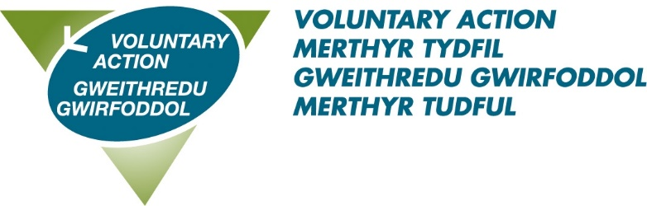

Job Title: Community Resilience Officer

About us: Voluntary Action Merthyr Tydfil (VAMT) is the County Voluntary Council (CVC) for the County Borough of Merthyr Tydfil and has existed since 1997. VAMT is a part of Third Sector Support Wales (TSSW) which is a network of support organisations for the third sector. Our shared goal is to enable the third sector and volunteers across Wales to contribute fully to individual and community well-being, now and for the future.

About this role: You will work collaboratively to support third sector organisations to develop and deliver warm hubs/spaces across Merthyr Tydfil particularly in response to the cost-of-living crisis.
To secure this great opportunity you will have: a proven track record of community development, an excellent understanding of funding, training and the governance needs of community groups, the ability to deliver training and arrange training packages, the ability to identify gaps in service provision and look for solutions to address those gaps and an ability to nurture and develop positive working relationships across all sectors.

Benefits of working with us:
- A flexible working scheme
- 28 days annual leave rising to 33 on completion of 5 years service
- 8 bank holidays
- 3 concessionary days
- Enhanced sick pay
- A very generous pension scheme – 10% employer contribution
- Agile Working
This post is subject to a successful 6 month probation period.
For an informal discussion about the role on 18th July, please contact: karen.vowles@vamt.net for the Teams link
To download an application pack please click here
Closing date: 31st July 2023
Interview date: 23rd August 2023

