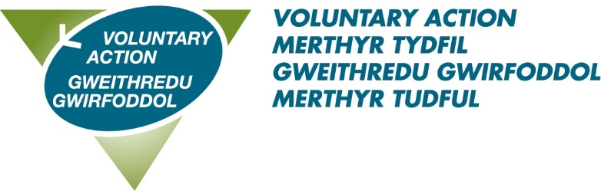
VAMT’s Volunteer Recognition Awards 2023
Thursday 1st June, 6.30pm at Morlais Gold Club, Merthyr Tydfil
Nomination information, rules and purpose of awards
Every year thousands of individuals and groups volunteer across the Merthyr Tydfil County Borough giving their time, energy, skills and commitment to help others in their community.
VAMT’s Volunteer Achievement Awards 2023 are designed to recognise and honour outstanding people and organisations that have made a significant contribution to our community. We would like to encourage people to nominate individuals and groups who you believe have made a significant contribution to the community through volunteering in the last year.
The awards are:
- Volunteer of the Year (25 and under)
- Volunteer of the Year (26 and over)
- Community/Charity group of the Year
- Trustee
- Outstanding Volunteer
Nomination procedure
- Individuals cannot be nominated by themselves, a partner, family member or any employee or Board member of Voluntary Action Merthyr Tydfil (VAMT). The nominator should have known the nominee for a minimum of six months;

- Nominees must have volunteered in the County Borough of Merthyr Tydfil during the past year;

- Nominations for the Community/Charity Group of the Year Award must be made by a volunteer, partner organisation or beneficiary from the nominated organisation;

- Organisations must be based or working within the Merthyr Tydfil County Borough;

- VAMT staff or any other paid workers are not eligible for the awards.

Rules for all categories:

Personal details provided on all nomination forms may be passed on to partner organisations and to the media for publicity purposes. If you are not willing for any information to be shared in this way or if you do not wish media organisations to contact the nominee or nominator, please let us know as soon as possible.

- Please note that whist all nominees will be recognised, only the highest scoring nominee will be selected for an award for each category.

- Please ensure that the information provided is relevant and unique to the nominee. The information should not be replicated or duplicated for another nominee.

- A selection panel will select the award winners.

- The panels decisions are final. The panel reserves the right not to make an award in any particular category if they feel that the nominations are not suitable. No feedback will be given on the panels decisions or discussions.
Closing date for nominations:

Completed nominations must be received by 12 noon on Friday 21st April 2023 using an official nomination form. Applications received after the closing date will not be considered.

Postal nominations must be marked ‘Private and confidential’ and should be returned to Frances Barry, 89-90 Pontmorlais, High Street, Merthyr Tydfil CF47 8UH.

Electronic versions should be emailed to frances.barry@vamt.net

To obtain further copies of the nomination form, information and rules, call VAMT’s Volunteer Centre on 07958 132822 or download the forms from the Volunteering Section at https://vamt.net/en/volunteering/volunteers-week-2023/

