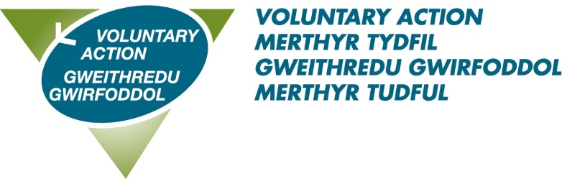

Voluntary Action Merthyr Tydfil
Volunteer Recognition Awards 2023
The categories

Young Volunteer of the Year (25 and under Award)

Open to young people between the ages of 14 - 25 on 31 March 2022, who have volunteered within the Merthyr Tydfil County Borough during the past year.

Volunteer of the Year (26 and over Award)

Open to adults over 25 who have volunteered within the Merthyr Tydfil County Borough during the last 12 months.

Community Group/Charity of the Year

Recognising the commitment given by local voluntary groups to provide a range of services across the county borough, which has provided a real benefit to the service users or community.
Trustee Award
This award is open to an individual Trustee that has provided support, guidance and direction to a voluntary or community group in the Merthyr Tydfil County Borough.

Outstanding Contribution Award

An individual volunteer whose commitment and longevity to voluntary work within the Merthyr Tydfil County Borough has contributed to and enhanced the wellbeing of the community.

