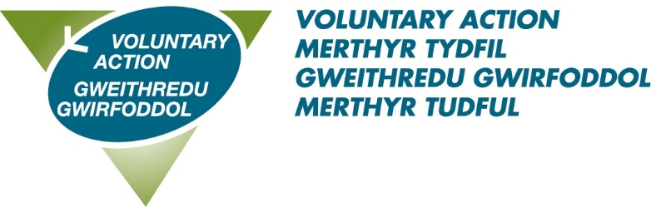

Voluntary Action Merthyr Tydfil
Volunteer Recognition Awards 2023
Nomination form
Details about you, the nominator:

Name:_____________________________________________________________

Address:____________________________________________________________

________________________ Postcode:_________________________________

Tel:_______________________________________________________________

Email: ____________________________________________________________

Details of person/group you are nominating:

Name:_______________________________ Group_______________________

Address:__________________________________________________________

__________________________ Postcode________________________________

Email______________________________________________________________

Award category nominated for (tick one category only):

VOLUNTEER OF THE YEAR AWARD (UNDER 25)

VOLUNTEER OF THE YEAR AWARD (25 AND OVER)

COMMUNITY/CHARITY GROUP OF THE YEAR

TRUSTEE

OUTSTANDING VOLUNTEER

Reason for nomination:
Why do you feel this person deserves an award? Please put as much information as succinctly possible. Please use no more than 300 words.

I confirm that the information I have given is correct to the best of my knowledge. I have read and agree to abide by the rules of the scheme.
Signed_______________________________________Dated________________
Electronic signature is sufficient.

Nomination rules are as follows:

- Nominations must be received by 12 noon on Friday 21st April 2023.

- The individual (or group where appropriate) must reside within the Merthyr Tydfil County Borough

- The individual/ group (where appropriate) must carry out its voluntary work within the Merthyr Tydfil Borough.

- Individuals cannot nominate themselves or be nominated by a family member.

- Nominators are asked to ensure that the nominee is aware and agreeable to the nomination being put forward.

- The judging panel’s decision is final.

Postal nominations must be marked ‘Private and confidential’ and should be returned to Frances Barry, VAMT – 89-90 Pontmorlais, High Street, Merthyr Tydfil, CF47 8UH

Electronic versions should be emailed to frances.barry@vamt.net

To obtain further copies of the nomination form, information and rules, call VAMT’s Volunteer Centre on 07958 132822 or download the forms from our volunteering section at www.vamt.net

