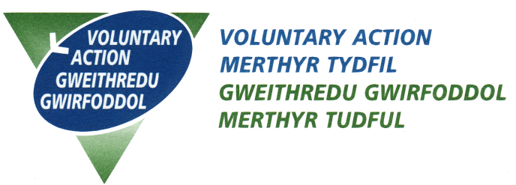
Equal Opportunities Monitoring Form

VAMT is committed to increasing equality and diversity within its workforce. As part of this we need information from applicants to check that our recruitment and selection procedures are reaching as many potential candidates as possible and are fair.

This form will be used to monitor how VAMT compares nationally (and locally) with regard to equal opportunities. It will not be held for any purpose other than monitoring. The information provided will be processed in accordance with the provisions of the General Data Protection Regulation and the Data Protection Act 2018. By signing below you are giving your consent to your data being processed in accordance with the enclosed Privacy Notice.

This form is optional and anonymous. It does not constitute any part of the recruitment and selection process and is separated from the application form on receipt by member of staff who is not involved in this recruitment and selection exercise.

1 Where did you learn about this job vacancy?……………………….…………

2 Please state your date of birth ……………………………..………..………………

3 Please tick which age group you fall into; 18-24 25-34 35-44
45-54 55-64 65-75

4 Are you (please tick); Male Female

5 What is your religion/faith?

……………………………………………………………………….…….……………
Prefer not to say

6 What is your sexual orientation? Gay Male Lesbian,
(please tick) Heterosexual Transgender
Bisexual
Prefer not to say

7 Do you have responsibility for dependants, i.e. children or elderly or other persons for whom you are the main carer? Yes No

8 If you have children under 18, please state their ages ……………….…………

Do any of your children under 18 have a disability? Yes No

9 Please describe your level of ability in the Welsh Language. Please tick box.
Fluent Basic Understanding
Advanced Learner None

10 Please indicate what your ethnic group is. Choose one section from A to E and tick the appropriate box.

A White British Irish Welsh
Scottish English
Any other White background, please write in ………………………….………

B Mixed White and Black Caribbean White Asian
White and Black African Any other Mixed background, please write in ………………………….………

C Asian or Asian British Indian, Bangladeshi,
Pakistani
Any other Asian background, please write in ..………………………………..

D Black or Black British Caribbean African
Any other Black background, please write in ………………………………….

E Chinese or other ethnic group Chinese
Any other, please write in …………………………………………..………………

Prefer not to say

11 Do you suffer from a recognised disability as outlined in the Equality Act 2010 (see below for definition)? If yes, please state what that disability is;

……………………………………………………………………………………………

……………………………………………………………………………………………

The Equality Act 2010 states that you must not discriminate in any form against anyone for reason of the following protected characteristics.

Age
Where this is referred to, it refers to a person belonging to a particular age (e.g. 32 year olds) or range of ages (e.g. 18 - 30 year olds).

Disability
A person has a disability if s/he has a physical or mental impairment which has a substantial and long-term adverse effect on that person's ability to carry out normal day-to-day activities.

Gender reassignment
The process of transitioning from one gender to another.

Marriage and civil partnership
Marriage is defined as a 'union between a man and a woman'. Same-sex couples can have their relationships legally recognised as 'civil partnerships'. Civil partners must be treated the same as married couples on a wide range of legal matters.

Pregnancy and maternity
Pregnancy is the condition of being pregnant or expecting a baby. Maternity refers to the period after the birth, and is linked to maternity leave in the employment context. In the non-work context, protection against maternity discrimination is for 26 weeks after giving birth, and this includes treating a woman unfavourably because she is breastfeeding.

Race
Refers to the protected characteristic of Race. It refers to a group of people defined by their race, colour, and nationality (including citizenship) ethnic or national origins.

Religion and belief
Religion has the meaning usually given to it but belief includes religious and philosophical beliefs including lack of belief (e.g. Atheism). Generally, a belief should affect your life choices or the way you live for it to be included in the definition.

Sex
A man or a woman.

Sexual orientation
Whether a person's sexual attraction is towards their own sex, the opposite sex or to both sexes.

