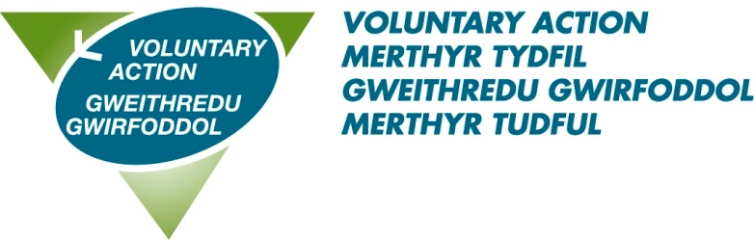

TITLE: BAME Engagement Officer

HOURS: 37 hours per week, fixed term until 30.11.21

SALARY: £23,398 pro rata

PENSION: 10% employer contribution

ANNUAL LEAVE: 28 days pro rata

ACCOUNTABLE TO: Health & Wellbeing Manager

LOCATION: Merthyr Tydfil

PURPOSE OF THE POST

The Black and Minority Ethnic (BAME) COVID-19 Engagement Officer’s purpose is to apply their knowledge of engagement with local BAME communities and work at a community level implementing a communications plan designed to increase BAME engagement with the Test Trace and Protect Service and COVID-19 information.

This is a temporary contract until 30th November 2021. The selected individual will be working as part of the VAMT team and will also work closely with the communications team(s) of the Regional Partnership Board, Local Authority and Test Trace and Protect work stream. They will also connect to a regional BAME Engagement Coordinator (yet to be appointed in the Health Board).

The BAME Engagement Officer will be given direction and guidance to implement the communications plan designed for the region across the community and provide appropriate feedback and progress to the Coordinator to inform decision making for improvement and development of the engagement project.

The fundamental aim of the Test and Trace Protect Workstream is to prevent the spread of Coronavirus. This is a newly formed team and will work in collaboration with other strategic bodies including Cwm Taf Morgannwg Health Board and Merthyr Tydfil County Borough Council.

The selected individual must be experienced in BAME outreach work with lived experience of BAME communities and community networks. They should be able to develop good relationships with local community groups and voluntary organisations.

Main duties and responsibilities

Community Engagement: Engage and empower BAME communities by delivering specific communications on TTP and Covid-19 in the way communities prefer to receive information, to ensure BAME communities are educated on preventative measures and understand what they should do in relation to a Covid-19 incident / cluster.

Debunking myths and misinformation: Respond quickly to circulated misinformation and identify ways to provide accurate messages.

Teamwork: Coordinate and work with different colleagues across the Test, Trace and Protect Service and external bodies, to maximise the effectiveness of the communications strategy provided.

Insights Gathering: Listen to communities, gather feedback to inform service delivery and demonstrate to communities how this has influenced decision making.

General requirements

- To observe confidentiality in all aspects of work.
- To demonstrate a willingness to undertake training development and learning opportunities to improve skills.
- To work within the organisations ethos, principles, policy and procedures in respect of equal opportunity, anti-discriminatory and anti-oppressive practices.
- You are responsible for undertaking your duties in a manner which safeguards and promotes the welfare of children, young people and adults at risk. You must bring issues of concern regarding the safety and welfare of children, young people and adults at risk to the attention of the Designated Officer. You must raise any concern or allegation of abuse and neglect without delay.
- To accept that this job description may be periodically subject to review.
- To undertake any other duties and/or times of work as may be reasonably required of you, commensurate with your grade or general level of responsibility within the organisation, at your place of work or based in any other establishment.

VAMT specific requirements

- Contributing to the VAMT newsletter and website
- Provide project reports as required by the funder
- Provide quarterly reports against the VAMT Operational Plan as required by the Board
- Reporting on the Customer Relationship Management system and updating information on contacts and organisations
- Attending and making good use of supervision
- Participating in internal working groups to further VAMT’s organisational and management development
- Undertaking other duties which are not detailed in this job description, but which meet VAMT’s aims to assist and support the work of the third sector.

PERSON SPECIFICATION
BAME ENGAGEMENT OFFICER

ESSENTIAL CRITERIA
Education/  Qualifications/  Knowledge | - Extensive knowledge of BAME Engagement processes  - One years’ experience of working in an engagement/outreach environment with BAME communities or other socially vulnerable communities
Experience | 2.1 Evidence of executing communications and outreach campaigns  2.2 Evidence of consistent outreach and engagement with marginalised groups.  2.3 Experience of delivering services in the BAME community either in a paid or unpaid position  2.4 Demonstrable experience of working with sensitive issues with diplomacy
Skills and abilities | 3.1 Evidence of gathering community insights through networks and discussions  3.2 Demonstrable ability to address false information, myths or misconceptions  3.2 Ability to carry out structured research including surveys  3.3 Ability to educate others through on-the-ground outreach work, including community discussions and handing out leaflets  3.4 The ability to develop relationships with community members on a grass roots level  3.5 Able to work to deadlines and tight timescales
Personal Attributes | 4.1 Resilience, integrity and sound judgement in a highly sensitive and political environment  4.2 Highly developed interpersonal skills to maintain credibility with decision makers at every level and respect within communities  4.3 A creative thinker able to work with little supervision  4.4 Strongly motivated and committed to professional development  4.5 Comfortable with giving advice and being highly visible in the organisation and the community  4.6 Access to a vehicle for work purposes
DESIRABLE CRITERIA
The ability to communicate in the welsh language

