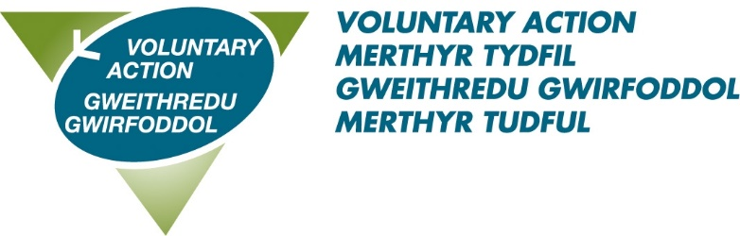

Job Title: Invest Local Ynysowen Development Officer – 37hrs per week**

About us: Voluntary Action Merthyr Tydfil (VAMT) is the County Voluntary Council (CVC) for the County Borough of Merthyr Tydfil and has existed since 1997. VAMT is a part of Third Sector Support Wales (TSSW) which is a network of support organisations for the third sector. Our shared goal is to enable the third sector and volunteers across Wales to contribute fully to individual and community well-being, now and for the future.

About this role:
The post holder will work with the Building Communities Trust Invest Local Officer, the Invest Local Ynysowen Steering Group, residents, volunteers, groups, stakeholders and partners to deliver the projects and programmes of work identified in the Driving Change plan. The role will engage with local residents and develop a sustainable volunteer base, build local capacity to develop a sustainable funding strategy to secure the long-term future of the community beyond the Invest local funding.
To secure this great opportunity you will have: excellent communication skills, the ability to work collaboratively across all sectors, excellent organisational skills, ability to support and manage volunteers, a proven track record in community development as well as an understanding of delivering against a development plan.

Benefits of working with us:
- A flexible working scheme
- 28 days annual leave (pro rata) rising to 33 on completion of 5 years’ service
- 8 bank holidays
- 3 concessionary days
- Enhanced sick pay
- A very generous pension scheme – 10% employer contribution
- Agile Working
**We are currently trialling a “4 Day Week” – this means 80% time for 100% salary and 100% output.
For an informal discussion about the role, please contact: karen.vowles@vamt.net
To download an application pack please click
Closing date: 17th May 2024 Interview date: 7th June 2024

