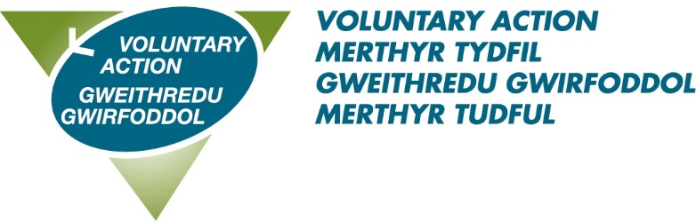
Voluntary Action Merthyr Tydfil
Volunteer Recognition Awards 2024
Details about you, the nominator:

Name:_____________________________________________________________

Address:____________________________________________________________

________________________ Postcode:_________________________________

Tel:_______________________________________________________________

Email: ____________________________________________________________

Details of person/group you are nominating:

Name:_______________________________ Group_______________________

Address:__________________________________________________________

__________________________ Postcode________________________________

Email______________________________________________________________

Award category nominated for (tick one category only):

YOUNG VOLUNTEER OF THE YEAR AWARD (UNDER 25)

VOLUNTEER OF THE YEAR AWARD (26 AND OVER)

GROUP

TRUSTEE

OUTSTANDING ACHIEVEMENT

Reason for nomination:

Why do you feel this person deserves an award?

Under the headings below, please put as much information as possible. The individual/group will be scored under each section so it’s important that we have as much relevant information as possible.

Briefly describe the commitment, dedication and length of service of individual/group (200 words)

What impact and contribution has the individual/group had to the local community? (200 words)

Describe an achievement/activity that you wish to highlight? (100 words)

Why should they receive special recognition? (100 words)

I confirm that the information I have given is correct to the best of my knowledge. I have read and agree to abide by the rules of the scheme.
Signed_______________________________________Dated________________
Electronic signature is sufficient.

Nomination rules are as follows:

- Nominations must be received by 12 noon on Friday 12th April 2024.

- The individual (or group where appropriate) must reside within the Merthyr Tydfil County Borough

- The individual/ group (where appropriate) must carry out its voluntary work within the Merthyr Tydfil Borough.

- Individuals cannot nominate themselves or be nominated by a family member.

- Nominators are asked to ensure that the nominee is aware and agreeable to the nomination being put forward.

- The judging panel’s decision is final.

Postal nominations must be marked ‘Private and confidential’ and should be returned to Frances Barry, Voluntary Action Merthyr Tydfil, Voluntary Action Centre, 89-90 Pontmorlais, High Street, Merthyr Tydfil, CF47 8UH

Electronic versions should be emailed to frances.barry@vamt.net

To obtain further copies of the nomination form, information and rules, call VAMT’s Volunteer Centre on 07958 132822 or download the forms from our website;

https://vamt.net/en/volunteering/celebrating-volunteering/

