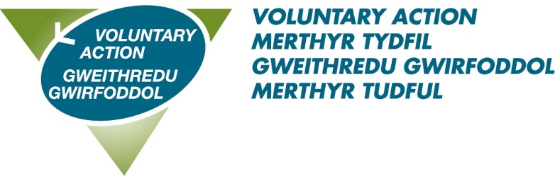

Our Strategic Aims
2022-2025

Aim 1: Enable third sector organisations to deliver services, improve in all aspects of their work and become resilient

We will: Provide advice, guidance and support on sustainable funding, governance and other aspects of organisational development

Outcome: Third sector staff, managers and trustees have the knowledge and skills they need to enable their organisation to operate sustainably, fairly, legally and safely.

Aim 2: Strengthen representation and influence of third sector organisation at a local, regional, and national level

We will: Support and facilitate networks, consultation, and opportunities for engagement in collaboration with members, partners, and stakeholders

Outcome: To ensure engagement and influence - the voice of the third sector is heard and effectively influences policy and decision making, and service design and delivery.
Aim 3: Enhance volunteering and wellbeing through participation and community engagement

We will: Provide support and guidance to individuals interested in volunteering, volunteer managers and organisations. Broker volunteering and provide ongoing support

Outcome: Individuals, the community and organisations benefit from volunteering involvement.

Aim 4: Enhance effectiveness of VAMT as an exemplar third sector organisation and strengthen its sustainability

We will: Continually review and improve internal governance and systems, ensuring compliance with legislation and best practice
We will: Secure and generate the resources needed to continue and grow to support and enhance the third sector

Outcome: Staff, managers and trustees have the knowledge and skills they need to enable VAMT to operate sustainably, fairly, legally and safely.
Aim 5: Continual improvement of VAMT’s Board and its effectiveness

We will: Adopt the Charity Commission and any other regulators best practice. Develop a Board action plan to identify opportunities for professional development.

Outcome: VAMT trustees are confident about leading the organisation and maintaining high standards of governance inline with the 7 principles of public life.

Our Mission:  To increase the extent, quality, and impact of Voluntary Action in the borough of Merthyr Tydfil by supporting, representing, and assisting the third sector organisations and volunteering.  Effecting change by enhancing the well-being of individuals, organisations and communities. | Our Vision:  To be the centre of excellence in Merthyr Tydfil for the provision of services to organisations and individuals involved with the third sector and volunteering.  To create a healthy community by helping to develop organisations to meet their needs, maximising volunteering opportunities and sharing our missions with all stakeholders. | Our Values:  We believe in and promote:  - Openness, honesty, transparency  - Professionalism and integrity  - Collaborative working  - Excellent governance  - Inclusion and diversity  - Sustainable change that makes a positive difference

