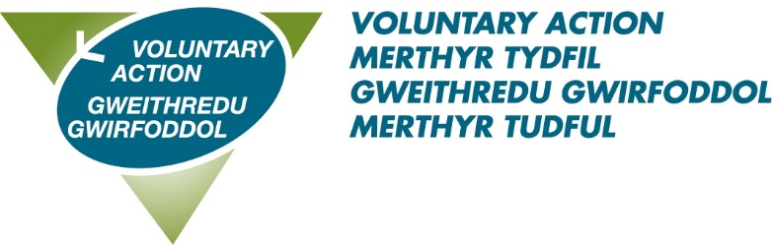

MINUTES OF BOARD MEETING HELD ON 25th OCTOBER 2021

(JM Room, Voluntary Action Centre)

Present: Paul Gray, Kayleigh Norval, Suzanne Davies, Mark Ward, and Anne Roberts (Via teams)

In attendance: Sharon Richards, Laura Johnson and Marian Barnes from Mitchell Meredith Accountants Ltd

Marian Barnes was welcomed to the meeting.

21/46 APOLOGIES

Nicola Mahoney, Michael Ronan, and Michelle Jones.

21/47 DECLARATIONS OF INTEREST IN AGENDA ITEMS

None
BUSINESS ITEMS

21/48 FEEDBACK FROM FINANCE COMMITTEE

Paul Gray advised that The Finance Committee had not met during this period. It was noted that the Admin/Finance Officer will now join the Finance Committee following the resignation of the Admin/Finance Manager.

21/49 AUDIT FINDINGS REPORT

Marian Barnes explained the audit findings report to the board and noted that she was still awaiting copied of Board minutes for the period. Marian highlighted some improvements that should be made when using SAGE Accounts. In addition, it was recommended that HMRC and pension payments are reconciled regularly and VAMT move towards a bank account that allows for payments to be made via dual authentication.
Action: Admin/Finance Officer

21/50 PRESENTATION OF DRAFT ACCOUNTS FOR YEAR ENDING 31.03.21

Marian Barnes presented the draft accounts to the Board drawing attention to increase in unrestricted funds and the strong balance sheet at year end. Marian mentioned the continued reduction in office costs from hybrid working contributing to the increase.

The accounts were accepted by Anne Roberts and seconded by Kayleigh Norval.

Marian Barnes was thanked by the Chair for her assistance in producing the audited accounts and left the meeting.

21/51 MANAGEMENT ACCOUNTS Q2

The Admin/Finance Officer explained the management accounts for Q2 to the Board members which were AGREED.

21/53 VAMT QUARTER 2 MONITORING

The Chief Officer presented the quarter 2 VAMT KPI report and the quarter 2 highlights report, demonstrating comparison with 2020.

Kayleigh Norval asked whether the Community Coordinator data is included in the KPI report. The Chief Officer explained that Community Coordinator roles are not consistent throughout TSSW and therefore data is captured on a separate CRM system.

Referencing the highlights report Suzanne Davies commented that it is comprehensive and detailed, enabling Board members to see staff impact. Kayleigh Norval added that it’s a brilliant achievement. Paul Gray also gave thanks to the Chief Officer.
Action: Chief Officer

21/54 CHIEF OFFICER’S REPORT

The Chief Officer’s report had been circulated in advance and was presented by the Chief Officer. The report was received by the Board and explained in detail. The content of the report was noted, with the Chief Officer drawing attention to the business plan which is being developed by TSSW. This will be actively reflected upon by the Chief Officer when developing the new VAMT strategic plan for 2022-2025.
Action: Chief Officer

21/55 AGM

The Chief Officer confirmed that based on VAMT governing documents, an AGM will need to take place this year. A suitable venue and facilities will be sourced to enable the AGM to be held in line with current Covid guidelines. The Trustees rotation schedule was confirmed by the Chief Officer.

It was agreed to reappoint Mitchell Meredith Ltd as Auditors for 2021/22. This was accepted by Mark Ward and seconded by Anne Roberts

Action: Admin/Finance Officer

21/56 HEALTH AND SAFETY REPORT

Nothing to report.

21/57 MEMBERSHIP

Two new members were APPROVED, bringing the number of members to 292. These are Qualia Law and Taff Rocks.

21/58 POLICY REVIEW

No new policies presented. An updated schedule to be presented at the next meeting.
Action: Chief Officer

21/59 MINUTES OF PREVIOUS MEETING HELD ON 26th JULY 2021

The minutes of 26th July 2021 were AGREED and are suitable for publishing on the website.
Action: Chief Officer

21/60 ACTION LOG

The Chief Officer advised that actions will be picked up by the Senior Management Team going forward and updates reported to Board meetings.
Action: Chief Officer

21/61 ANY OTHER BUSINESS

Suzanne Davies advised the Board that a meeting of the Community Trust is planned for January. The Trust would welcome a representative from VAMT and ask that the Board consider a contribution to the fund.
Action: Chief Officer

21/61 DATE OF NEXT MEETING

The next full meeting is on Monday 31st January at 2pm.

MEETING CLOSED
Signed: ………………………………………….
Date: …………………………………………

