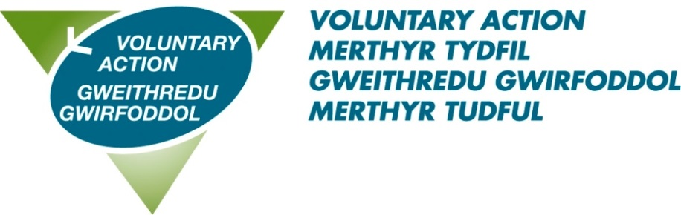

MEMBERSHIP APPLICATION FORM

Organisation Name

Name of Main Contact

Role of Main Contact

Correspondence Address

Postcode

Telephone for main contact

E-Mail

Website

Facebook

Twitter

Brief outline of organisation’s aims

Legal status | Please give details as appropriate
Unincorporated
Charity Commission Number
Companies House Number
Charitable Incorporated Organisation (CIO)
Community Interest Company (CIC)
Cooperative
Registered Friendly Society
Registered Social Landlord
Industrial Provident Society
Registered Community Amateur Sports Club
Please state the geographical area in which your organisation operates
Does your organisation provide room hire etc, which can be accessed by other groups? | Yes / No
If yes, please list facilities available & current cost

Please select the categories that best describes the work of your organisation. This information is required in order to collate statistics about the Third Sector in Wales
Advice and advocacy |  | Financial Advice
Animal welfare |  | Funding
Arts, culture and heritage |  | Gender
Benefits advice |  | Health and Social Care
Benevolent organisations |  | Housing
Carers |  | Intermediaries
Children and families |  | International Aid & Emergency relief
Community |  | Mental health
Community justice |  | Neurological conditions
Dementia |  | Older People
Disability |  | Religion
Education and training |  | Sport and recreation
Employment |  | Volunteering
Environment |  | Youth
Ethnic minorities |  | Other categories – please state

Special Interest – please tick all that apply. This information is required in order to collate statistics about the Third Sector in Wales
BME
Disabled group
Faith group
Age
Gender
Sexuality
Welsh language

If your organisation would like to be on the mailing lists for the following Forums and Networks, please complete below
Forum | Name | Email
VAMT Health & Well Being Forum
VAMT Environment and Green Spaces Network
VAMT Volunteering Interest Mailing List
Regional Social Value Forum
Regional Dementia Care Forum
Regional Volunteer Managers Forum
Regional Mental Health Forum

DATA PROTECTION - The information provided will be processed in accordance with the provisions of the General Data Protection Regulation and the Data Protection Act 2018. By signing below you are giving your consent to your data being processed in accordance with the Privacy Notice which can be found at http://www.vamt.net/privacy-eng.php

Declaration
I hereby apply for membership of Voluntary Action Merthyr Tydfil on behalf of
(organisation): …………………………………………………………………………………………….
Signed: …………………………………………………………………………………………………....
Print Name: ………………………………………………………………………………..……………..
Position: ……………………………………………………………………………………………………
Date: …………………………………………………………………………………………..…………..

Please send completed form to Voluntary Action Merthyr Tydfil, 89-90 Pontmorlais, High Street, Merthyr Tydfil, CF47 8UH or by email to laura.johnson@vamt.net

